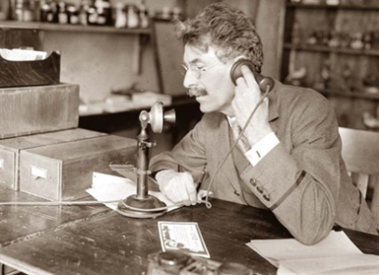 |  | 
Verleden tijd | Tegenwoordige tijd | Toekomst
Past | Present | FUTURE
Past Simple | Present Simple | Will/ Shall
Present Perfect | Present Continuous | Going to

 | Going to  Ik zal gaan werken | Will / Shall  Ik wil gaan werken
When to use | Geplande activiteiten die al vast staan. | Will: Ongeplande activiteiten die nog kunnen veranderen.  Shall: aan de start van een vragende zin als het onderwerp ‘I’ of ‘We’ is.
Rule | Am/ are/ is going to + ww | Will/ shall + ww
How | I am going to + ww  You are going to + ww  She/ He/ It is going to + ww  We are going to + ww  They are going to + ww | I will + ww Shall I + ww?  You will + ww Will you +ww?  She/ He/ It will + ww Will she + ww?  We will + ww Shall we + ww?  They will + ww Will they + ww?
Signifier | Certainly  No doubt  Sure to happen  Definitely  Absolutely | I think  Probably  Sometime  Once  Maybe

Going to

- Fill in gaps. You can choose from: am going to / are going to / is going to.
- We ____________________ buy a new hamster wheel this weekend.
- I ____________________ work in a zoo when I leave school.
- He ____________________ run very fast to catch his bus after class.
- Roely and Esmee ____________________watch Vampire Diaries, like they do every Friday.
- What ______you___________ have for lunch this afternoon?

Will / Shall

- Fill in gaps. You can choose from: will / shall.
- I think it ____________________ rain this afternoon because the sky is grey.
- ____________________ we buy those tickets now or later?
- Rowdy ____________________ carry your bags if they are not too heavy.
- Michael ____________________ eat those sandwiches because they smell funky.
- ____________________ Michiel and Nikki finish these assignments first?

Going to & Will / Shall

- Circle the correct form of the Future tense.
- Peter knows that he (will / is going to) fly to Chicago next week.
- Oh no! I've broken the vase. What (is my mum going to say / will my mum say)?
- Look at those clouds! It (is going to rain / will rain)!
- (Shall/Will) we feed the horses now or later?
- (Shall/Will) you help me carry the bags?
- Someday I (will be / am going to be) a millionaire because I’m working hard to be one.
- We (are going to / will go to) the cinema tonight.
- My stomach is hurting. I (am going to / will) have some tea.

- Fill in the gaps. You can choose from: am going to / are going to / is going to / will / shall
or won’t (= will not).
- This weekend I ____________________ eat all the chips I can because I made a bet.
- You ____________________ do exactly as I say mister!
- Wessel ____________________ pick up his parents from the airport tomorrow.
- ____________________ I close the window now?
- My sister ____________________ the dentist next week.
- ____________________ you go to PSV’s next home game with me?
- Do you know if they ____________________ go to the school dance next month?
- Max Verstappen ____________________ ever win a grand prix if his car keeps breaking down.
- We ____________________ be the best gardeners after we leave this school.
- Sam and Sharon ____________________ ace this assignment because they get it!

